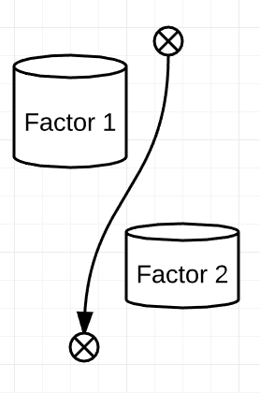This level is exactly the same as Level 3. It is meant to introduce obstacles that will be frequently used later in the game. Obstacles are our visual interpretations of certain functions in your code. We tried to simplify programming as much as it possibly can be, and this is the result.

Suppose, you have certain functions that must be executed depending on a criterion. In order to follow the criterion, you will introduce specific actions that will be executed in different ways depending on the situation. In the programming world, where you have to be aware of so many factors (even more than in A-level Mechanics!), it is extremely important to consider mostly all of them. Thus, this simple idea of obstacles allows to have defined assumptions about the behaviour of the character (mars explorer), and therefore teaches to develop computing considerations, predictions. *See Figure 1 for further reference.*

In real world, it might be ridiculously viable to have correct assumptions. As an example, there was an occasion when a racket exploded not reaching anywhere near final destination. After long and thorough analyses, the mistake was found – the code rounded one ‘small’ value. Being round – it is not anymore precise enough, but no one could anticipate that such small error could cause such significant consequences.

Figure 1: Correct considerations